**ASSIGNMENT QUESTION:**

Build a python code, assume you get temperature and humidity values (generated with random function to a variable) and write a condition to continuously detect alarm in case of high temperature.

PYTHON CODE:

import random

import time

while(1!=0):

temperature = random.random()

humidity = random.random()

print("Temperature: ","%.5f" % temperature)

print("Humidity: ","%.5f" % humidity)

time.sleep(2)

if (temperature > 0.7):

print("high temperature")

if ( humidity >0.7):

print("high humidity")

print("")

EXECUTION RESULT

**Program :**

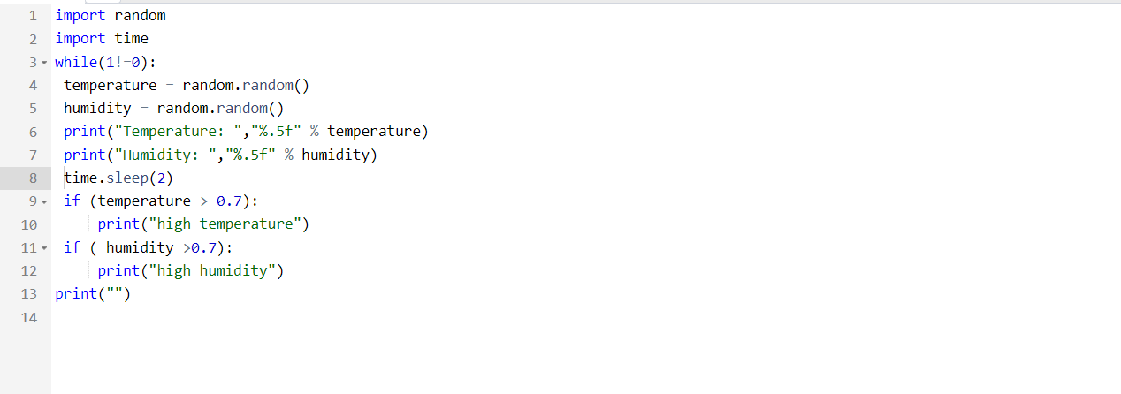

**OUTPUT :**

